

Team 6

Operation Hermes



January 30, 2020

Johnathan Kinslow, Jose Salazar, Austin Minks, McKenzie Ledonne, Thanh Le, Spencer Peace

Contents

Team 6 Project 2

Software Testing Environment 2

Importance of a Test Planning Process 2

Characteristics of Test Plans 2

Test Planning Approach 2

Approach Taken 2

Test Planning Outline 2

Scope 2

System Description and Operation 3

Test Identification 3

Test Levels 3

Planned Tests 3

Test Schedule 4

Requirement Traceability Matrix 5

Summary 5

References 5

# Team 6 Project

## Software Testing Environment

For this software, it is important for the team to have the necessary skills involved in order to successfully design and implement the software. For this project, the team leader is Johnny Kinslow. His skills include C, C++, C#, HTML, CSS, PHP, JavaScript, Python, Java, and SQL. The build manager for this team is Spencer Peace. He has experience with C, C#, Java, Ruby, Python, SQL, and PHP. Thanh Tung Le is the team’s tester and debugger. His skills are in HTML, CSS, JavaScript, Java, PHP, SQL, and C++. The project manager is McKenzie Ledonne. She has experience with C, C++, HTML, CSS, SQL, and Java. The team’s configuration manager is AJ Minks. His skills include C, C++, Java, SQL, HTML, CSS, PHP, and Python. Jose Salazar is the team’s version control manager. His skills are Java, Python, SQL, HTML, CSS, JavaScript, Ruby, PHP, Angular, Git, Power BI, AWS, and Google Cloud. All members of the team are also working as developers for the project.

## Importance of a Test Planning Process

The test planning process is paramount to the overall testing process itself. A software development team must approach testing in a methodical, pre-planned way in order to ensure accuracy of results across the entire project. Without a plan for future testing, developers may develop in a manner that is hard-to-test instead of developing software that supports native testing. The latter method of test planning lends itself to enhanced inter-team communication and cross-functional teams skilled in both software development and software testing.

## Characteristics of Test Plans

Test plans will be generalized to handle a wide variety of test cases, but also specialized enough to fully test the functionality of modules. Tests will be well-planned and well-thought-out, designed by both frontend and backend developers with the end-user experience in mind. This will allow us to form a better cross-functional team and design better tests for future sprints.

# Test Planning Approach

## Approach Taken

Our approach is testing to critique. After the application being built, we will design test cases to examine if whether we offer enough functionalities, whether the scope of our software is reasonable, does the software run fast enough or effectively, etc. To implement front-end testing, we will use Vue.js built-in testing tools and for our back-end server, we will use Postman and manual checking tests. These tools are very helpful for unit-testing. For integration testing, we plan to write our own testing automation program.

# Test Planning Outline

## Scope

The testing scope includes data input functions, database management, user interface usability, data analysis informativeness and visuality, and information security.

## System Description and Operation

## Test Identification

## Test Levels

Progress through the Project will be monitored by a “Ring System.” The Ring system will be where testing will either prove a pass or fail, and if there are no major issues, and less than 2 minor issues, then the program goes into the next ring segment. There are 4 “rings” we will be working through, Alpha, Beta, Postproduction, and Release.

## Planned Tests

* User Login
* User Logout
* User Scopes (Users have access to specific functionality)
* Document scan
* Employee input
* Data analysis functions
* Database operations
* API’s CRUD operations

## Test Schedule

(<https://docs.google.com/spreadsheets/d/12bfyJ64CK7gGMc0CY0d7oe60OUo2VgY_iVl2grccmc4/edit#gid=0>)

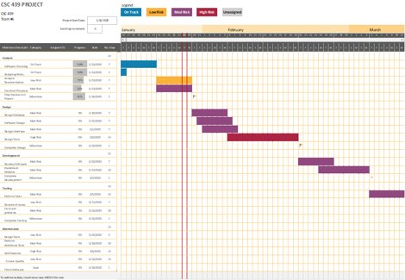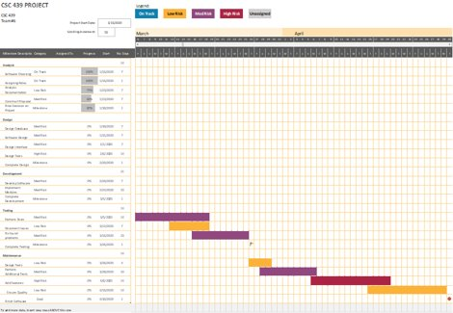

## Requirement Traceability Matrix

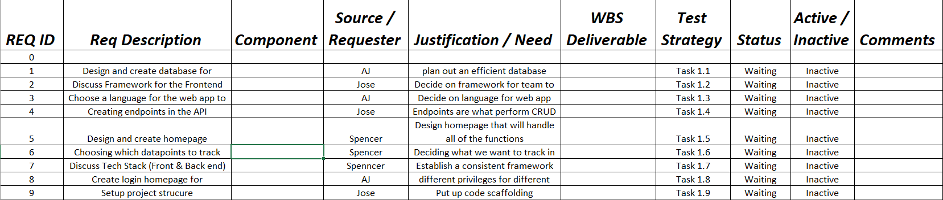

# Summary

This project is designed for accessibility and system continuity. Through the ability to send information through the system and have it updated immediately is incredibly useful in a corporate setting where timing means everything. We plan to work through the entire process and preform actions to better the development cycle of the program and for the team. With Operation Hermes, we plan on giving the company the ability to work with the systems to give them the data they need most.

# References

[None for this Unit]